МІНІСТЕРСТВО ОСВІТИ І НАУКИ УКРАЇНИ

НАЦІОНАЛЬНИЙ УНІВЕРСИТЕТ “ЛЬВІВСЬКА ПОЛІТЕХНІКА”

ІНСТИТУТ КОМП’ЮТЕРНИХ НАУК ТА ІНФОРМАЦІЙНИХ ТЕХНОЛОГІЙ

кафедра систем штучного інтелекту



**ЗВІТ**

про виконання лабораторної роботи №4

з курсу «Проектування систем глибинного навчання»

на тему Автоенкодеритаїхтипи.Імплементація за допомогоюKeras»

Виконав:

*ст. групи КНСШ-12*

*Карпінський Р.М*

Перевірив:

*Пелешко Д.Д*

ЛЬВІВ – 2021

**Мета:** Виконати задані завдання за темою Автоенкодеритаїхтипи.Імплементація за допомогоюKeras.

**Завдання.**

* Провести дослідження двох автоенкодерів, що описані вище(глибокий автоенкодер та конволюційний автоекодер).
* Поміняти параметри моделі глибокого автоекодера длядосягненнябільшої точності і провести декілька експериментів.
* Поміняти параметри моделі конволюційного автоекодера, можливододати ще шари конволюції та пулінга (upsampling) і перебудуватиархітектуру моделі.
* Дослідити який з автоекодерів виділяє локальні особливості кращеіна яких даних.
* Спробувати по різному нанести шум на зображення і задопомогоюавтоенкодера відновити дані.

**Виконання роботи:**

from keras.layers import Dense, Input, Conv2D, LSTM, MaxPool2D, UpSampling2D

from sklearn.model_selection import train_test_split

from keras.callbacks import EarlyStopping

from tensorflow.keras.utils import to_categorical

from numpy import argmax, array_equal

import matplotlib.pyplot as plt

from keras.models import Model

from imgaug import augmenters

from random import randint

import pandas as pd

import numpy as np

train = pd.read_csv("fashion-mnist_train.csv")

train_x = train[list(train.columns)[1:]].values

train_y = train['label'].values

## normalize and reshape the predictors

train_x = train_x / 255

## create train and validation datasets

train_x, val_x, train_y, val_y = train_test_split(train_x, train_y, test_size=0.2)

## reshape the inputs

train_x = train_x.reshape(-1, 784)

val_x = val_x.reshape(-1, 784)

input_layer = Input(shape=(784,))

## encoding architecture

encode_layer1 = Dense(1500, activation='relu')(input_layer)

encode_layer2 = Dense(1000, activation='relu')(encode_layer1)

encode_layer3 = Dense(500, activation='relu')(encode_layer2)

## latent view

latent_view = Dense(10, activation='sigmoid')(encode_layer3)

## decoding architecture

decode_layer1 = Dense(500, activation='relu')(latent_view)

decode_layer2 = Dense(1000, activation='relu')(decode_layer1)

decode_layer3 = Dense(1500, activation='relu')(decode_layer2)

## output layer

output_layer = Dense(784)(decode_layer3)

model = Model(input_layer, output_layer)

model.compile(optimizer='adam', loss='mse')

early_stopping = EarlyStopping(monitor='val_loss', min_delta=0, patience=10, verbose=1, mode='auto')

model.fit(train_x, train_x, epochs=20, batch_size=2048, validation_data=(val_x, val_x), callbacks=[early_stopping])

*Output exceeds the [size limit](vscode-file://vscode-app/c:/Users/Akeno/AppData/Local/Programs/Microsoft%20VS%20Code/resources/app/out/vs/code/electron-browser/workbench/workbench.html" \o "command:workbench.action.openSettings?[\"notebook.output.textLineLimit\"]). Open the full output data[in a text editor](vscode-file://vscode-app/c:/Users/Akeno/AppData/Local/Programs/Microsoft%20VS%20Code/resources/app/out/vs/code/electron-browser/workbench/workbench.html" \o "command:workbench.action.openLargeOutput?18a0bbe6-9b70-4d01-b164-489d6791dd98)*

Epoch 1/20

24/24 [==============================] - 8s 330ms/step - loss: 0.0926 - val_loss: 0.0678

Epoch 2/20

24/24 [==============================] - 7s 303ms/step - loss: 0.0637 - val_loss: 0.0564

Epoch 3/20

24/24 [==============================] - 7s 304ms/step - loss: 0.0499 - val_loss: 0.0435

Epoch 4/20

24/24 [==============================] - 7s 297ms/step - loss: 0.0409 - val_loss: 0.0378

Epoch 5/20

24/24 [==============================] - 7s 297ms/step - loss: 0.0369 - val_loss: 0.0353

Epoch 6/20

24/24 [==============================] - 7s 309ms/step - loss: 0.0333 - val_loss: 0.0310

Epoch 7/20

24/24 [==============================] - 7s 303ms/step - loss: 0.0293 - val_loss: 0.0275

Epoch 8/20

24/24 [==============================] - 8s 318ms/step - loss: 0.0268 - val_loss: 0.0258

Epoch 9/20

24/24 [==============================] - 7s 300ms/step - loss: 0.0254 - val_loss: 0.0250

Epoch 10/20

24/24 [==============================] - 8s 320ms/step - loss: 0.0242 - val_loss: 0.0239

Epoch 11/20

24/24 [==============================] - 7s 305ms/step - loss: 0.0233 - val_loss: 0.0229

Epoch 12/20

24/24 [==============================] - 7s 299ms/step - loss: 0.0224 - val_loss: 0.0241

Epoch 13/20

24/24 [==============================] - 8s 315ms/step - loss: 0.0195 - val_loss: 0.0189 Epoch 19/20 24/24 [==============================] - 7s 299ms/step - loss: 0.0186 - val_loss: 0.0184 Epoch 20/20 24/24 [==============================] - 7s 307ms/step - loss: 0.0183 - val_loss: 0.0181

<keras.callbacks.History at 0x21ad095dee0>

preds = model.predict(val_x)

from PIL import Image

f, ax = plt.subplots(1,5)

f.set_size_inches(80, 40)

for i in range(5):

    ax[i].imshow(val_x[i].reshape(28, 28))

plt.show()

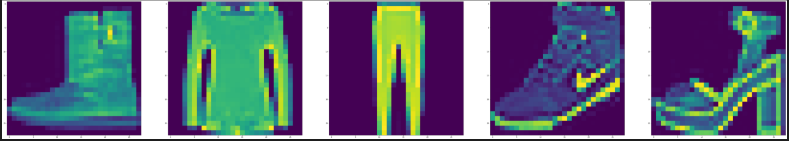

f, ax = plt.subplots(1,5)

f.set_size_inches(80, 40)

for i in range(5):

    ax[i].imshow(preds[i].reshape(28, 28))

plt.show()

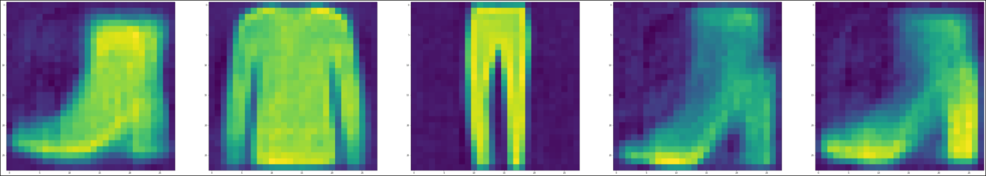

train_x = train[list(train.columns)[1:]].values

train_x, val_x = train_test_split(train_x, test_size=0.2)

## normalize and reshape

train_x = train_x/255.

val_x = val_x/255.

train_x = train_x.reshape(-1, 28, 28, 1)

val_x = val_x.reshape(-1, 28, 28, 1)

# Lets add sample noise - Salt and Pepper

noise = augmenters.SaltAndPepper(0.1)

seq_object = augmenters.Sequential([noise])

train_x_n = seq_object.augment_images(train_x * 255) / 255

val_x_n = seq_object.augment_images(val_x * 255) / 255

f, ax = plt.subplots(1,5)

f.set_size_inches(80, 40)

for i in range(5,10):

    ax[i-5].imshow(train_x[i].reshape(28, 28))

plt.show()

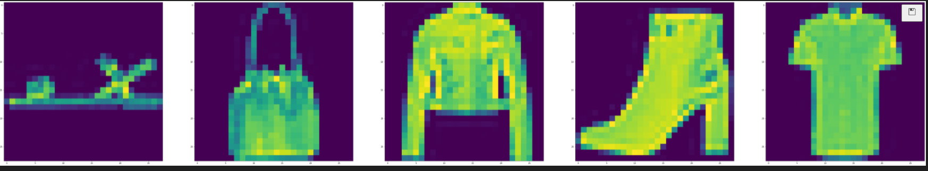

f, ax = plt.subplots(1,5)

f.set_size_inches(80, 40)

for i in range(5,10):

    ax[i-5].imshow(train_x_n[i].reshape(28, 28))

plt.show()

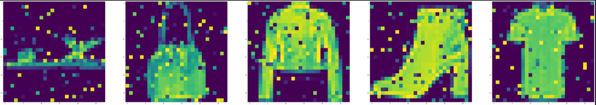

input_layer = Input(shape=(28, 28, 1))

# encoding architecture

encoded_layer1 = Conv2D(64, (3, 3), activation='relu', padding='same')(input_layer)

encoded_layer1 = MaxPool2D( (2, 2), padding='same')(encoded_layer1)

encoded_layer2 = Conv2D(32, (3, 3), activation='relu', padding='same')(encoded_layer1)

encoded_layer2 = MaxPool2D( (2, 2), padding='same')(encoded_layer2)

encoded_layer3 = Conv2D(16, (3, 3), activation='relu', padding='same')(encoded_layer2)

latent_view = MaxPool2D( (2, 2), padding='same')(encoded_layer3)

# decoding architecture

decoded_layer1 = Conv2D(16, (3, 3), activation='relu', padding='same')(latent_view)

decoded_layer1 = UpSampling2D((2, 2))(decoded_layer1)

decoded_layer2 = Conv2D(32, (3, 3), activation='relu', padding='same')(decoded_layer1)

decoded_layer2 = UpSampling2D((2, 2))(decoded_layer2)

decoded_layer3 = Conv2D(64, (3, 3), activation='relu')(decoded_layer2)

decoded_layer3 = UpSampling2D((2, 2))(decoded_layer3)

output_layer = Conv2D(1, (3, 3), padding='same')(decoded_layer3)

# compile the model

model_2 = Model(input_layer, output_layer)

model_2.compile(optimizer='adam', loss='mse')

model_2.summary()

*Output exceeds the [size limit](vscode-file://vscode-app/c:/Users/Akeno/AppData/Local/Programs/Microsoft%20VS%20Code/resources/app/out/vs/code/electron-browser/workbench/workbench.html" \o "command:workbench.action.openSettings?[\"notebook.output.textLineLimit\"]). Open the full output data[in a text editor](vscode-file://vscode-app/c:/Users/Akeno/AppData/Local/Programs/Microsoft%20VS%20Code/resources/app/out/vs/code/electron-browser/workbench/workbench.html" \o "command:workbench.action.openLargeOutput?16dab4b8-15c5-4dc3-b2b4-449310294250)*

Model: "model_1"

_________________________________________________________________

Layer (type) Output Shape Param #

=================================================================

input_2 (InputLayer) [(None, 28, 28, 1)] 0

_________________________________________________________________

conv2d (Conv2D) (None, 28, 28, 64) 640

_________________________________________________________________

max_pooling2d (MaxPooling2D) (None, 14, 14, 64) 0

_________________________________________________________________

conv2d_1 (Conv2D) (None, 14, 14, 32) 18464

_________________________________________________________________

max_pooling2d_1 (MaxPooling2 (None, 7, 7, 32) 0

_________________________________________________________________

conv2d_2 (Conv2D) (None, 7, 7, 16) 4624

_________________________________________________________________

max_pooling2d_2 (MaxPooling2 (None, 4, 4, 16) 0

_________________________________________________________________

conv2d_3 (Conv2D) (None, 4, 4, 16) 2320

_________________________________________________________________

up_sampling2d (UpSampling2D) (None, 8, 8, 16) 0

_________________________________________________________________

conv2d_4 (Conv2D) (None, 8, 8, 32) 4640

_________________________________________________________________

up_sampling2d_1 (UpSampling2 (None, 16, 16, 32) 0

================================================================= Total params: 49,761 Trainable params: 49,761 Non-trainable params: 0 _________________________________________________________________

early_stopping = EarlyStopping(monitor='val_loss', min_delta=0, patience=10, verbose=5, mode='auto')

history = model_2.fit(train_x_n, train_x, epochs=10, batch_size=2048, validation_data=(val_x_n, val_x), callbacks=[early_stopping])

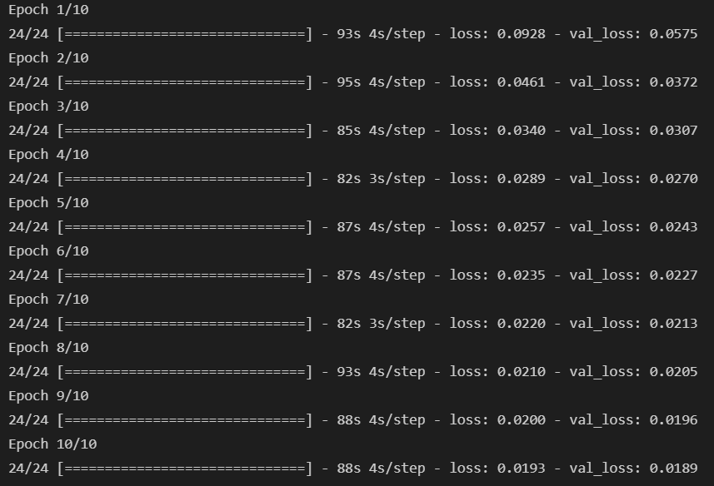

preds = model_2.predict(val_x_n[:10])

f, ax = plt.subplots(1,5)

f.set_size_inches(80, 40)

for i in range(5,10):

    ax[i-5].imshow(preds[i].reshape(28, 28))

plt.show()

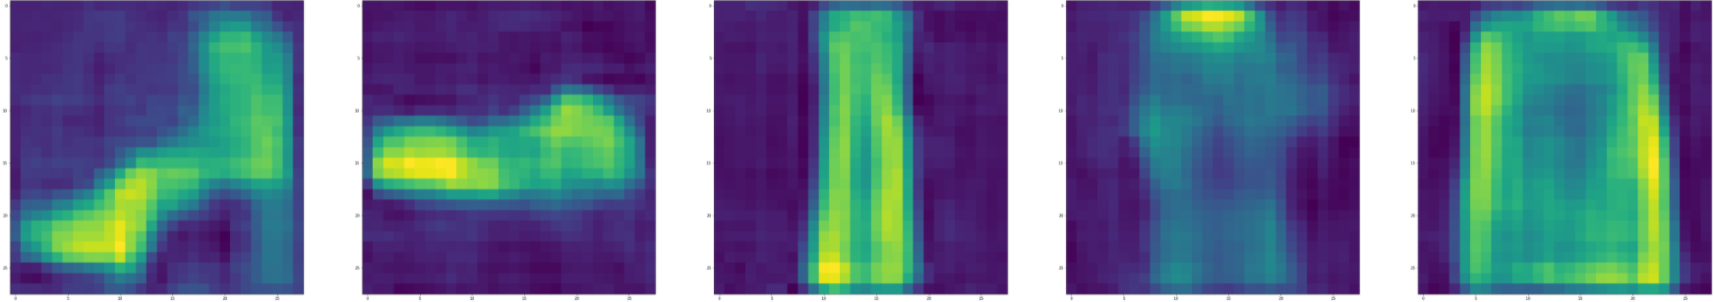

**Висновок:** На даній лабораторній роботі, виконав поставлені завдання а саме: провів дослідження двох автоенкодерів, поміняв параметри моделі глибокого автоекодера, поміняв параметри моделі конволюційного автоекодера, дослідив який з автоекодерів виділяє локальні особливості, спробував по різному нанести шум на зображення